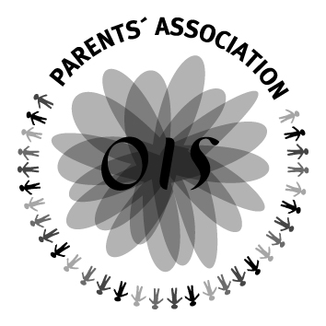
OISPA Overall Achievement Awards 2020
APPLICATION FORM

NAME:
HAVE YOU BEEN A STUDENT AT OIS FOR AT LEAST IB1 and IB2?
PLEASE LIST YOUR IB SUBJECTS (INCLUDING LEVEL) AND STATE WHY YOU CHOSE THEM.

The following questions should be answered with a maximum of 250 words. Only the first 250 words are assessed.
PLEASE LIST YOUR CAS ACTIVITIES STATING THE AMOUNT OF TIME SPENT DOING EACH ACTIVITY, WHY YOU CHOSE THOSE ACTIVITIES AND WHAT YOU THINK HAS BEEN GAINED BY THOSE AROUND YOU AND/OR BY YOU IN DOING THESE ACTIVITIES.

PLEASE LIST ANY OTHER EXTRA CURRICULAR ACTIVITIES OR HOBBIES IN WHICH YOU PARTICIPATE.

WHAT PLANS DO YOU HAVE FOR WHEN YOU LEAVE OIS? PLEASE GIVE DETAILS OF ANY COLLEGE PLACES YOU HAVE BEEN OFFERED (WHERE AND WHAT YOU PLAN TO STUDY) AND/OR ACTIVITY YOU PLAN TO UNDERTAKE IN A GAP YEAR, INCLUDING HOW MUCH TIME YOU WILL SPEND DOING THE ACTIVITY.

BRIEFLY DESCRIBE WHY YOU HAVE CHOSEN YOUR PARTICULAR COURSE OR GAP YEAR ACTIVITY

DO YOU HAVE ANY IDEAS ABOUT LONGER TERM PLANS/CAREER?

IF YOU WIN THIS AWARD, HOW WILL YOU USE THE MONEY?

WHAT WILL YOU DO IF YOUR PLANS FOR NEXT YEAR FALL THROUGH?

